FTC Credibility---Sports Betting

FTC Cred---1AC

Advantage---1AC

Advantage [x]---FTC CREDIBILITY:

FTC credibility is in shreds.
Fred Ashton 23, BA in Economics from Penn State, MS in Applied Economics from U of Maryland, Director of Competition Policy @ American Action Forum; February 14; The Hill, “The FTC’s Populist Push Is Jeopardizing Its Credibility,” https://thehill.com/opinion/finance/3831531-the-ftcs-populist-push-is-jeopardizing-its-credibility/, jay
Much ink has been spilled lamenting the Federal Trade Commission’s (FTC) marked shift away from its long-standing consumer welfare standard and toward a populist approach of targeting big business, notably tech companies. Less studied is what this means for the agency’s ability to accomplish its core mission: protecting the public from deceptive or unfair business practices and unfair methods of competition.
Under the direction of Chair Lina Khan, the FTC has abandoned its decades-long adherence to the consumer welfare standard of antitrust enforcement under which mergers, acquisitions and other business behaviors are subject to intervention only when they are likely to harm consumers. This standard necessarily imposes a narrow range of considerations on which regulators can focus and has served well to protect consumers from unfair business practices. Khan’s FTC instead has expanded its range of considerations to cover size, industry concentration and other ancillary factors. In doing so, the agency is pushing the bounds of its congressionally mandated scope and authority.
This shift has led the agency to file a number of high-profile merger challenges, several targeting big tech companies. These tactics reflect the FTC’s desire to expand its power. The agency is attempting to push the bounds of its authority and, if it cannot do so, hopes that Congress comes to its rescue and fills in the gaps FTC leadership believes exist in current antitrust law. As Khan herself has said, “Even if it’s not a slam dunk case, even if there is a risk you might lose, there can be enormous benefits from taking the risk.”
This strategy has racked up a number of very avoidable losses in court for the FTC — and these losses have consequences for the agency. Bringing lawsuits with weak economic evidence and legal theories unsupported by modern case law risks setting new precedents that could hinder future cases in which actual consumer harm is significant. Moreover, continuing to bring such cases to trial endangers any deference courts would traditionally afford to the agency.
The FTC’s lack of success in following its “big is bad” theory of harm not only wastes valuable agency resources but jeopardizes its credibility, as well. Each time the FTC engages in a long-shot endeavor to expand the bounds of its authority or challenge a merger that lacks traditional economic rigor, the agency erodes its own credibility among the courts. Judges, over time, may become less likely to believe the agency is acting within its proper remit, and they may question its neglect of empirical economic reasoning focused on the consumer.

Public opposition to sports betting legalization is growing rapidly.
John Gramlich 25, Associate Director @ Pew Research Center, MA in Journalism and Public Affairs from American U, BA in English from Penn State; October 2; Pew Research Center, “Americans increasingly see legal sports betting as a bad thing for society and sports,” https://www.pewresearch.org/short-reads/2025/10/02/americans-increasingly-see-legal-sports-betting-as-a-bad-thing-for-society-and-sports/, jay
Public awareness of legal sports betting has grown in recent years – and so has the perception that it is a bad thing for society and sports, according to a new Pew Research Center survey.
Growing shares of Americans view legal sports betting as bad for society and sports
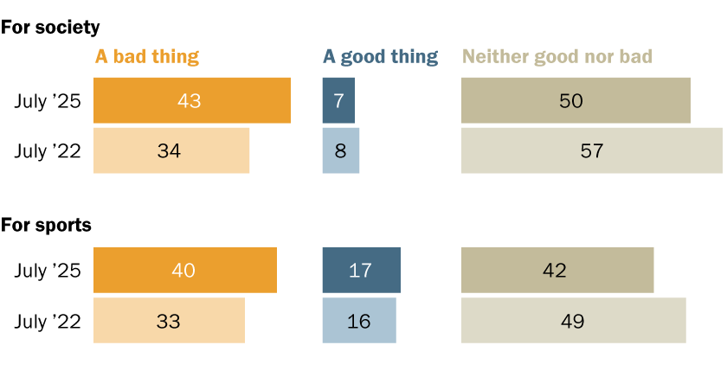
Today, 43% of U.S. adults say the fact that sports betting is now legal in much of the country is a bad thing for society. That’s up from 34% in 2022. And 40% of adults now say it’s a bad thing for sports, up from 33%.
<<CONDENSED, NONE OMITTED>>
Despite these increasingly critical views of legal sports betting, many Americans continue to say it has neither a bad nor good impact on society and on sports. Fewer than one-in-five see positive impacts. Meanwhile, the share of Americans who have bet money on sports in the past year has not changed much since 2022. Today, 22% of adults say they’ve personally bet money on sports in the past year. That’s a slight uptick from 19% three years ago. This figure includes betting in any of three ways: With friends or family, such as in a private betting pool, fantasy league or casual bet Online with a betting app, sportsbook or casino In person at a casino, racetrack or betting kiosk 1 in 10 U.S. adults now say they have placed an online sports bet in the past year All of this increase has come through online sports betting: 10% of adults now say they’ve placed a bet this way in the past year, up from 6% in 2022. There has been no change in the shares of adults who have bet on sports with family or friends or in person at a casino, racetrack or betting kiosk. Commercial sports betting has spread rapidly across the United States since a Supreme Court ruling in 2018 gave states the green light to legalize it. At least 38 states, the District of Columbia and Puerto Rico now allow commercial sports betting in some form, according to the National Conference of State Legislatures. In our new survey, 63% of adults say they’ve heard or read a lot or a little about the fact that sports betting is now legal in much of the U.S. That’s up from 56% in 2022. The increase in public awareness comes as betting-related advertisements have become common during sports broadcasts. The rest of this analysis takes a closer look at Americans’ views of and experiences with sports betting. It’s based on the survey of 9,916 U.S. adults, conducted in July and August.
<<PARAGRAPH BREAKS RESUME>>
Many demographic groups increasingly view legal sports betting as a bad thing
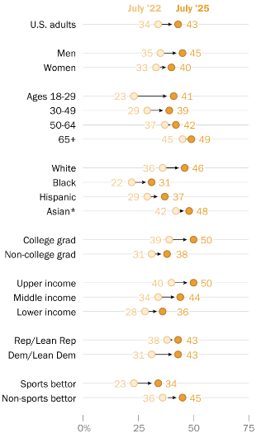
Since 2022, Americans in many demographic groups have become more likely to view the widespread legalization of sports betting as a bad thing for society, as well as for sports.
This is true for men and women; college graduates and non-college graduates; and upper-, middle- and lower-income Americans alike. It is also the case among Democrats and Republicans, as well as among those who have personally placed a sports bet in the past year and those who have not.
Some of the biggest shifts in attitudes about sports betting’s societal impact have come among young Americans – especially young men. Today, 47% of men under 30 say legal sports betting is a bad thing for society, up from 22% who said this in 2022. Women under 30 have also become more likely to express this view: 35% see legal sports betting as bad for society, up from 25% three years ago.
The legalization of sports betting has generated revenue for state governments and gambling operators, but it has also raised concerns about gambling addiction and other societal harms. Critics have also cautioned that it may compromise the integrity of sports. In recent years, several professional and college athletes and team personnel have been punished for violating betting rules.

2AC

Case

Uniqueness

Uniqueness---2AC

FTC credibility is in the floor. Greed led them to prioritize going after tech giants over consumer well-being. That’s not their job. On top of that, baseless lawsuits deck their credibility in the courtroom. That’s Ashton.

Uniqueness---Ext---Losing Cases

They’re chasing fake cases with failing sophistry.
Jay Ezrielev 23, PhD in Economics from NYU, Adjunct Prof. of Economics @ Johns Hopkins U; August 11; ProMarket, “Why Does the FTC Continue To Pursue Losing Cases?,” https://www.promarket.org/2023/08/11/the-ftc-takes-another-l-why-is-the-agency-continuing-to-pursue-bad-cases/, jay
In yet another setback to the Federal Trade Commission’s competition agenda against Big Tech, a district court rejected the agency’s bid to block the Microsoft/Activision Blizzard transaction. The FTC’s appeals to the Ninth Circuit Court of Appeals and the Supreme Court were to no avail. The Microsoft/Activision Blizzard loss follows the agency’s loss in its challenge of the Meta/Within transaction. These losses raise questions about the agency’s judgment in pursuing bad cases and what it might do differently.
The two cases share many similarities. The acquirers in both transactions are Big Tech firms. Both merger challenges were decided by district court judges appointed by Democratic presidents, Judge Edward J. Davila (appointed by President Barack Obama) overseeing the Meta/Within case and Judge Jacqueline Scott Corley (appointed by President Joe Biden) overseeing the Microsoft/Activision Blizzard case, both in the Northern District of California. In both cases, the main theories of harm did not imply a loss of current competition between the merging parties. In Meta/Within, the FTC challenged the transaction based on the “actual potential competition” and “perceived potential competition” theories where the main concern is the loss of potential future competition. The FTC challenged the Microsoft/Activision Blizzard transaction based on vertical theories of harm. The Agencies (the FTC and Department of Justice Antitrust Division) rarely litigate potential competition and vertical merger cases and have a poor record in winning such cases in court. What the Microsoft/Activision Blizzard and Meta/Within cases also have in common is that the FTC’s evidence in both cases was shockingly weak.
<<CONDENSED, NONE OMITTED>>
In Meta/Within, the FTC focused its challenge on the effect of the transaction on competition in the supply of virtual reality (VR) dedicated fitness apps. Within’s Supernatural is the most popular VR dedicated fitness app, whereas Meta did not have its own VR dedicated fitness app. In its complaint, the FTC alleged that Meta was a potential entrant in the VR dedicated fitness app market and that Meta’s acquisition of Within would eliminate potential future competition between Meta and Within. The threshold issue for the court was whether there was “reasonable probability” or a “likelihood noticeably greater than fifty percent” of Meta’s entry in the “VR dedicated fitness app market” in the absence of the Meta/Within transaction. The court found the FTC’s theory of harm to be “impermissibly speculative” as it also found that “Meta lacked certain capabilities that are unique and critical to the VR dedicated fitness app market.” Finding no evidence that Meta considered building a VR fitness app on its own, the court concluded that “it is not reasonably probable that Meta would enter the market for VR dedicated fitness apps” in the absence of the Meta/Within transaction. Because the FTC did not meet its burden of demonstrating “reasonable probability” of Meta’s entry, the court did not proceed to the next, even more difficult to establish element of the FTC’s case: “whether Meta’s de novo entry was substantially likely to deconcentrate or result in other procompetitive effects in the relevant market.” In Microsoft/Activision Blizzard, the main issue of contention was whether the merged firm would withhold Activision’s popular Call of Duty game from Sony PlayStation, Microsoft’s gaming console competitor. The court found that there was “overwhelming evidence of the combined firm’s lack of incentive to pull Call of Duty from PlayStation,” including commitments from Microsoft to continue providing Call of Duty on PlayStation and to expand access to Call of Duty to other vendors. The FTC alleged that Microsoft would have financial incentives to withhold Call of Duty from PlayStation based primarily on the economic analysis of Professor Robin Lee. However, the court found Lee’s analysis to be based on unsupported assumptions and so plagued with errors as to render it unreliable. The court rejected the FTC’s other evidence and legal arguments as either unpersuasive or irrelevant to the analysis of the competitive effects at issue. In the end, there was not a shred of evidence offered by the FTC that the court found credible in supporting the agency’s case.
<<PARAGRAPH BREAKS RESUME>>
Why would the FTC spend significant taxpayer-funded resources and risk harm to its reputation in bringing cases based on such weak evidence, especially under the theories of harm that are difficult for the agencies to substantiate in court? The FTC’s willingness to bring difficult cases based on extremely weak evidence is the most puzzling aspect of the two FTC cases. There are several alternative explanations for why the FTC brought these cases.

Uniqueness---AT: Monopoly Turn---2AC

Monopolies is wrong.

1. CREDIBILITY---Credibility is a prerequisite to FTC functioning because judges need to believe that they are bringing legitimate cases to the courtroom. Otherwise, challenging monopolies is impossible.

2. FAILS---FTC attempts to go after monopolies are fruitless. That’s Ashton.
<<FOR REFERENCE>>
This shift has led the agency to file a number of high-profile merger challenges, several targeting big tech companies. These tactics reflect the FTC’s desire to expand its power. The agency is attempting to push the bounds of its authority and, if it cannot do so, hopes that Congress comes to its rescue and fills in the gaps FTC leadership believes exist in current antitrust law. As Khan herself has said, “Even if it’s not a slam dunk case, even if there is a risk you might lose, there can be enormous benefits from taking the risk.”
This strategy has racked up a number of very avoidable losses in court for the FTC — and these losses have consequences for the agency. Bringing lawsuits with weak economic evidence and legal theories unsupported by modern case law risks setting new precedents that could hinder future cases in which actual consumer harm is significant. Moreover, continuing to bring such cases to trial endangers any deference courts would traditionally afford to the agency.
The FTC’s lack of success in following its “big is bad” theory of harm not only wastes valuable agency resources but jeopardizes its credibility, as well. Each time the FTC engages in a long-shot endeavor to expand the bounds of its authority or challenge a merger that lacks traditional economic rigor, the agency erodes its own credibility among the courts. Judges, over time, may become less likely to believe the agency is acting within its proper remit, and they may question its neglect of empirical economic reasoning focused on the consumer.

Uniqueness---AT: Misinformation---2AC

The FTC does not stop misinfo.

1. CREDIBILITY---It makes the FTC function significantly better. Means affirming solves misinfo better.

2. PARTISIAN---Right-winged approaches to media regulations by the FTC ruin free speech.
Aaron Edlin 25; PhD in Economics and JD from Stanford, Prof. of Economics @ UC Berkeley; and Carl Shapiro, BS and PhD in Economics from MIT, Served on Obama’s Council of Economic Advisers, Prof. of Economics @ UC Berkeley; May 1; ProMarket, “The FTC Is Threatening Free Speech,” https://www.promarket.org/2025/05/01/the-ftc-is-threatening-free-speech/, jay, brackets are original
Ferguson asserts that he is a champion of free speech, but his actions as FTC chair show the opposite. He is using the FTC’s powers to discourage or prevent social media platforms from freely choosing which content to include, feature, promote, or monetize. Those choices are an integral part of how social media platforms compete. They are also a form of speech.
Moreover, Ferguson’s approach is highly partisan, as exemplified by his explanation for why he is not concerned with the dangers of misinformation: “This is not only because I categorically dismiss elite and democrat [sic] hysteria over misinformation altogether, but also because I believe that a highly concentrated social media space generates far more opportunities for elite and left-wing manipulation than it does for populist so-called misinformation.” He has previously made clear the partisan basis for his views, stating: “‘Misinformation,’ of course, being Newspeak for ideas and speech inconsistent with progressive orthodoxy.”
Ferguson’s partisan use of the FTC’s powers should concern everyone who favors the rule of law and everyone who opposes government interference with free speech.

